Java Programming
Section 4.2 practice
- B. Rishitha
- 192324130
Update accountgenerator Program:

import java.util.regex.*;

public class AccountGenerator {
public static void main(String[] args) {
// Example input (could be obtained from a user or another source)
String input = "John Doe"; // Replace with actual input logic

// Regular expression to match "one or more characters followed by a space and one or more characters"
String regex = "^[\\p{L}]+ [\\p{L}]+$";

// Create a Pattern object
Pattern pattern = Pattern.compile(regex);
// Create matcher object
Matcher matcher = pattern.matcher(input);

if (matcher.matches()) {
System.out.println("Valid name format.");
} else {
System.out.println("Incorrect format for name");
}
}
}
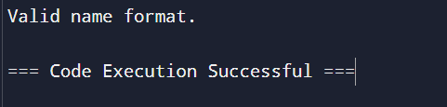

Decipher Coded Answer Key

import java.util.regex.*;
import java.io.*;

public class AnswerKeyProblem {
public static void main(String[] args) {
BufferedReader codedAnswers = null;
try {
// Attempt to open the file
codedAnswers = new BufferedReader(new FileReader("CodedAnswerKey"));
String line;
StringBuilder answers = new StringBuilder();

// Regular expression to match valid answer characters
String regex = "^[aAbBcCdDeEfF]$";
Pattern pattern = Pattern.compile(regex);

// Read each line and check if it matches the pattern
while ((line = codedAnswers.readLine()) != null) {
Matcher matcher = pattern.matcher(line);
if (matcher.matches()) {
answers.append(line);
}
}

// Print the collected answers
System.out.println(answers.toString());

} catch (FileNotFoundException e) {
System.err.println("The file 'CodedAnswerKey' was not found.");
} catch (IOException e) {
System.err.println("An error occurred while reading the file.");
} finally {
try {
if (codedAnswers != null) {
codedAnswers.close();
}
} catch (IOException e) {
System.err.println("Failed to close the file reader.");
}
}
}
}

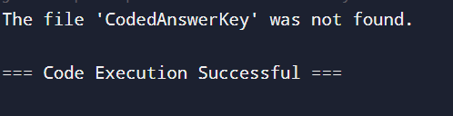

Replace Characters and Convert to Lower Case

public class AnswerKeyProcessor {
public static String finalAnswers(String answers) {
// Replace 'e' with 'b', 'E' with 'A', 'f' with 'c', and 'F' with 'D'
answers = answers.replaceAll("e", "b")
.replaceAll("E", "A")
.replaceAll("f", "c")
.replaceAll("F", "D");

// Convert to lower case
return answers.toLowerCase();
}

public static void main(String[] args) {
// Example answers string
String answers = "eE fF";
// Process the answers
String processedAnswers = finalAnswers(answers);
// Print the result
System.out.println(processedAnswers);
}
}

